* Storage account can be used for Application Queues.
* <https://docs.microsoft.com/en-us/azure/service-bus-messaging/service-bus-azure-and-service-bus-queues-compared-contrasted>
* We can create a queue in Storage accounts to store small bits of data for the use of other applications.
* We can get the various URL’s in the properties section of storage accounts.
* Service Bus: <https://docs.microsoft.com/en-us/azure/service-bus-messaging/service-bus-messaging-overview>
* 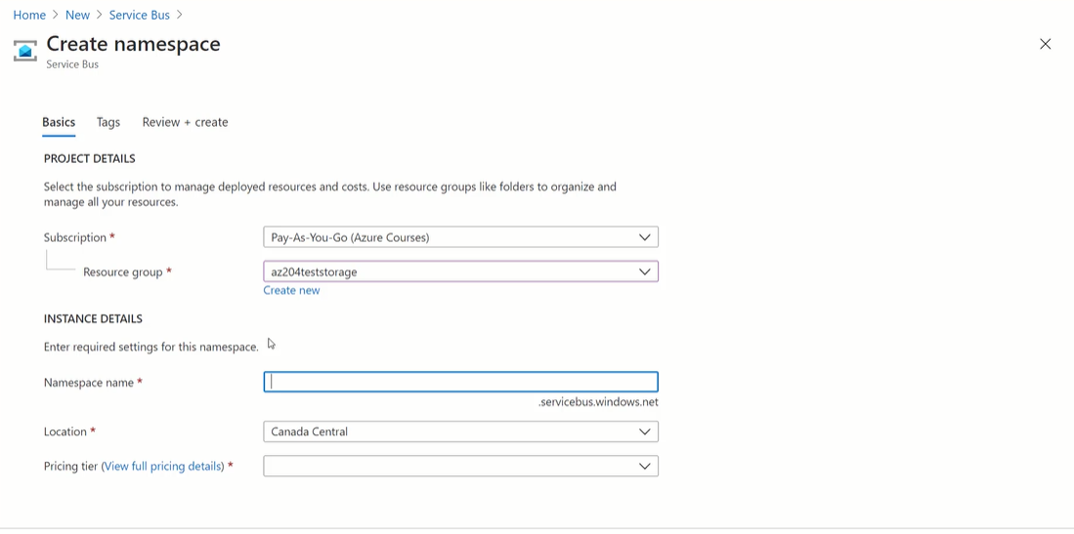
* Service Bus Pricing